A

Seminar Report

On

“Implementation of K-Means Clustering Algorithm using Parallel Computation Cluster”

Submitted in partial fulfilment of the requirements

of the UG Fellowship (URFU)

by

Mr. Abhijeet R. Daptardar Mr. Omkar H. Katkar
Mr. Shrinivas S. Survase Mr. Rohan S. Pawar
Mr. Mitesh U. Balwan

Under the Guidance of

Prof. Redikultsev Evgeniy


Department of Civil Engineering,
Ural Federal University,Russia.
2017 – 2018

ACKNOWLEDGMENT

It is our proud privilege and duty to acknowledge the kind of help and guidance received from several people in preparation of this report. It would not have been possible to prepare this report in this form without their valuable help, cooperation and guidance. First and foremost, we wish to record our sincere gratitude to Management of VIMEET and to SUMMER UNIVERSITY(URFU), for their constant support and encouragement in preparation of this report and for making available library and laboratory facilities needed to prepare this report. Our sincere thanks to Prof. Redikultsev Evgeniy , Head of Department of Civil Engineering, Ural Federal University Russia, for his valuable suggestions and guidance throughout the period of this report.

We express our sincere gratitude to our coordinator Mrs. Ekaterina Lyubimova , Department of international programs, Ural Federal University Russia, for guiding us in investigations for this seminar and in carrying out experimental work. We hold her in esteem for guidance, encouragement and inspiration received from them. We sincere thanks to coordinators of URFU for their continuous guidance, visit to different structures and sparing valuable time for giving us good industrial exposure. The report on “Precast Concrete Structures of Multiple Store Buildings” was very helpful to us. Their contributions and technical support in preparing this report are greatly acknowledged.

Mr. Abhijeet R. Daptardar. Mr. Omkar H. Katkar.
Mr. Mitesh U. Balwan . Mr. Shrinivas S. Survase.
Mr. Rohan S. Pawar.

ABSTRACT

The construction industry is significant in the development of the Indian
economy towards its realization of achieving vision 2020 to attain the status of a fully developed nation. Until 2020 the population of India will be approximately 1.35 billion and the government must be able to provide basic need such that shelter to everyone considering middle class and poor people around the country. To achieve this mission the Indian government is undertaking various small scale and large scale construction projects amalgamating with private sector as PPP. As construction industry is growing enormously the new methods of building constructions are introduced, which are flexible, high quality, cheap, and less time consuming. The precast concrete construction is now-a-days highly recommended construction technique in India, as project should be completed within time and with quality work various civil engineers consigning this new technique. Due to its low cost, low weight and speedy construction PCC is preferable then RCC. As precast construction fulfils all the safety requirements like RCC according to Indian standards (IS Code) the construction industry in India is taking new leap by considering this futuristic approach which will help to accomplish the vision 2020 .

Keywords: Precast construction , RCC, PPP, IS Code etc.

ACKNOWLEDGEMENT
ABSTRACT
INDEX
LIST OF FIGURES
LIST OF TABLES
INDEX

- INTRODUCTION | 09
- LITERATURE SURVEY | 10
3. TYPES OF PRECAST STRUCTURE  3.1 Large panel system  3.2 Framed system  - Slab-column system with sheer walls  3.3.1 Lift slab system with walls  3.3.2 Pre-stressed slab-column system | 16  16  17  18
4. PRECAST STRUCTURAL ELEMENT
4.1 Precast concrete floor system
4.1.1 Flat slab floors
4.1.2 Hollow core concrete slab floors
4.1.3 Double T floor

5. TYPICAL CONNECTIONS OF PRECAST CONCRETE ELEMNTS
6. RESULTS AND DISCUSSIONS 28
7. SUMMARY AND CONCLUSION 29
8. REFERANCES 30

LIST OF TABLE
TABLE NO. | TITLE OF TABLE | PAGE NO.
 | Schedule of reinforcement table | 22

LIST OF FIGURES

FIG.NO. | TITLE | PAGE NO.
 | Large panel concrete building under construction | 11
 | Framed system | 12
 | Precast slab | 16
 | Precast girders | 17
 | Cross section of a precast flat slab floor | 18
 | Cross section of hollow-core concrete slab floor | 19

INTRODUCTION

The construction industry in India is significantly increasing in size as more and more advance techniques are introduced, due to the least space availability in metropolitan cities the construction needs to be tall and safe from various hazards and which should tolerate all kinds of loads. As usual methods of construction like RCC structures are lot more heavier for multiple stored buildings, new methodologies are introduced in civil industry. Precast concrete structures are modified and recent construction technique which is better then RCC in many aspects. As PCC structures are lighter and more durable then RCC, it is advantageous to built multiple stored buildings. Considering the project schedule and deadline, faster the construction, economical the overall project will be. So PCC is more preferable by civil engineers. In precast concrete construction precast concrete blocks are sometimes made in industry and then they are carried to construction sites or sometimes they are prepared on site to avoid travel expenditure, this is to make project more economical in every aspect. In this type of construction beams, columns, slab panels are already precasted or sometimes a total slab is also prepared by precast techniques and then they are placed at particular point, then joints are made due to this technique work gets accomplished with more speed. Civil engineers need to consider safety measures and durability of the construction and this type of construction follows every aspect of engineers every point of view. Due to fast construction and considering economical aspect this type of technique is getting famous in India .

2. REVIEW OF LITERATURE

Bindurani.P in December 2013 studied an efficient alternative for building
construction. The behaviour of a precast system depends on connections and it should be modelled properly in the computational models for analysis and design. This study presented the modelling of connections in a wall type precast building system. A case study on a 23-storeyed building, made up of precast wall panels and slabs, to study the modelling of vertical joints in terms of shear transfer, is presented in the paper. Two computational models were investigated to find the effect of modelling the vertical joints between the wall panels, on the drifts and the generated forces in the walls. It was observed that the model, which was not considering any shear transfer through the vertical joints, tend to provide conservative results in terms of amount of steel requirement. The emulative monolithic wall system seems to be adequate in moderate seismic zones. The provisions of tie reinforcements, reinforced shear keys and dowel bars provide the required structural integrity for the precast system to avoid progressive collapse.
Fabio Biondini et al in February 2011, studied about the structural members of
precast one-storey or low-rise multi-storey concrete frames for industrial or commercial buildings are often directly exposed to the environment without any
protection. The aim of this paper is to investigate the seismic performance of this type of structure considering the material degradation induced by the diffusive attack of aggressive agents, like sulphate and chloride, that may lead to deterioration of concrete and corrosion of reinforcement. The time-variant structural performance of the critical cross-sections of the columns, where plastic hinges are expected to occur during a seismic event, is investigated in terms of bending moment versus curvature relationships. Push-over and push-pull cyclic analyses are then carried out over the structural lifetime to assess the global structural performance in terms of base shear forces and displacement ductility. In this way, even though the lifetime evolution of the dynamic behaviour under ground motion is not captured, it can be shown how the hierarchy of member strengths, and hence the energy-dissipating failure mode claimed for a capacity design of the structure, can be affected by the time-evolution of damage. The proposed procedure is applied to investigate the lifetime seismic performance of one-storey and three-storey frame structures. The results show a significant reduction of both base shear strength and displacement ductility over the structural lifetime and highlight the importance of a lifetime approach to seismic
assessment and design of concrete structures. Recent research investigations demonstrated that precast structures, under condition of a proper capacity design of connections, can achieve the same seismic performance of cast-in-place structures interms of global strength and ductility.
S.K. Ghosh et al in November 2006, inferred that precast concrete structures could be built in areas of high seismicity, such as California, only under an enabling provision of the ACI 318 Building Code Requirements for Structural Concrete, which is adopted by all model codes used in the country. The provision allows precast concrete construction in a highly seismic area “if it is demonstrated by experimental evidence and analysis that the proposed system will have a strength and toughness equal to or exceeding those provided by a comparable monolithic reinforced concrete structure”. The enforcement of this vague, qualitative requirement was, for obvious reasons, nonuniform. The need for specific enforceable design requirements for precast structures in regions of high seismicity was apparent for quite some time.
J. Witzany, T. Cejka & R. Zigler in October 2010, presented the results of an
experimental and theoretical analysis of the response of a prefabricated wall structure of a multi-story building to technical seismicity effects. The experimental investigation employed a model of a seven-story carrying prefabricated wall structure of a prefabricated panel building in the scale of 1:3. The model of the prefabricated structure was gradually exposed to eight loading states, includ-ing the cyclic and monotonously rising loading. The cyclic load induced by Tira-vib electrodynamic exciter simulated technical seismicity effects. The drop of stiffness of the prefabricated system was monitored in the first place by measuring relative displacements between the wall units and the deformation of the whole system in horizontal, as well as vertical direction. Based on the analysis of the experimental
results of the response of a prefabricated experimental system to a dynamic load, a relatively high level of the reliabil-ity and resistance of similar load-bearing prefabricated wall systems of multi-story buildings to the effects of standard technical seismicity with the frequency spectrum of seismic response and the magnitude of the seismic load within the verified scope may be reported.
Stefano Pampanin in June 2010, studied major advances have been observed in the last decade in seismic engineering with further refinements of performance-based seismic design philosophies and definition of corresponding compliance criteria. Following the worldwide recognized expectation and ideal aim to provide a modern society with high seismic performance structures, able to sustain a design level earthquake with limited or negligible damage, emerging solutions have been developed for high-performance, still cost-effective, seismic resisting systems, based on adequate combination of traditional materials and available technology. In this paper, an overview of recent developments and on-going research on precast concrete buildings with jointed ductile connections, is given. These recently developed highseismic resisting systems, able to undergo inelastic deformation during a major seismic event with minor structural damage and re-centering capability, represent a major achievement in seismic engineering in the last decade and could be possibly considered a fundamental milestone in the historical development in the field.

3. TYPES OF PRECAST SYSTEMS
Depending on the load-bearing structure, precast systems can be divided into the following categories:
i. Large-panel systems
ii. Frame systems
iii. Slab-column systems with walls
iv. Mixed systems
3.1 LARGE PANEL SYSTEMS
The designation “large-panel system” refers to multistory structures composed of large wall and floor concrete panels connected in the vertical and horizontal directions so that the wall panels enclose appropriate spaces for the rooms within a building. These panels form a box-like structure. Both vertical and horizontal panels resist gravity load. Wall panels are usually one story high. Horizontal floor and roof panels span either as one-way or two-way slabs. When properly joined together, these horizontal elements act as diaphragms that transfer the lateral loads to the walls. Depending on the wall layout, there are three basic configurations of large-panel buildings:
1) Cross-wall system: The main walls that resist gravity and lateral loads are placed in the short direction of the building.
2) Longitudinal-wall system: The walls resisting gravity and lateral loads are placed in the longitudinal direction; usually, there is only one longitudinal wall, except for the system with two longitudinal walls developed in Kazakhstan.
3) Two-way system: The walls are placed in both directions

Fig. 3.1: Large panel concrete building under construction

3.2 FRAME SYSTEMS
Precast frames can be constructed using either linear elements or spatial beam-column sub-assemblages. Precast beam-column sub-assemblages have the advantage that the connecting faces between the sub-assemblages can be placed away from the critical frame regions; however, linear elements are generally preferred because of the difficulties associated with forming, handling, and erecting spatial elements. The use of linear elements generally means placing the connecting faces at the beam-column junctions. The beams can be seated on corbels at the columns, for ease of construction and to aid the shear transfer from the beam to the column. The beam-column joints accomplished in this way are hinged. However, rigid beam-column connections are used in some cases, when the continuity of longitudinal reinforcement through the beam-column joint needs to be ensured.

The components of a precast reinforced concrete frame are shown in Figure.
Fig. 3.2: Frame system
3.3 SLAB- COLUMN SYSTEMS WITH SHEAR WALLS
These systems rely on shear walls to sustain lateral load effects, whereas the slab-column structure resists mainly gravity loads. There are two main systems in this category:
i. Lift-slab system with walls
ii. Pre stressed slab-column system
3.3.1 Lift slab system with walls
In the Lift –slab system, the load-bearing structure consists of precast reinforced
concrete columns and slabs. Precast columns are usually two stories high. All precast structural elements are assembled by means of special joints. Reinforced concrete slabs are poured on the ground in forms, one on top of the other. Precast concrete floor slabs are lifted from the ground up to the final height by lifting cranes. The slab panels are lifted to the top of the column and then moved downwards to the final position.

3.3.2 Pre stressed slab-column system
The pre stressed slab-column system uses horizontal pre stressing in two orthogonal directions to achieve continuity. The precast concrete column elements are 1 to 3 stories high. The reinforced concrete floor slabs fit the clear span between columns. After erecting the slabs and columns of a story, the columns and floor slabs are prestressed by means of prestressing tendons that pass through ducts in the columns at the floor level and along the gaps left between adjacent slabs. After prestressing, the gaps between the slabs are filled with in situ concrete and the tendons then become bonded with the spans. Seismic loads are resisted mainly by the shear walls (precast or cast-in-place) positioned between the columns at appropriate locations.

4.PRECAST STRUCTURAL ELEMENTS
Precast concrete building structures include beams, column, frame, slab panel, folded plate or shell stairs and wall panels. These structures can be very well designed as gravity load and seismic load resisting system.
Fig. 4.1: Precast slab
Fig. 4.2: Precast girders
4.1 PRECAST CONCRETE FLOOR SYSTEMS
A few common types of pre-cast concrete floors used in New Zealand are discussed:
(i) flat slab floor (ii) hollow-core concrete slab floor and (iii) double-tee floor.
4.1.1 Flat slab floors
Flat slab floors can provide economic solutions up to 6 m span. It consists generally of a series of 75 mm thick precast, pre stressed concrete slabs with a reinforced concrete topping. The slabs are usually 1.2 m or 2.4 m wide, and require 75 mm end seating.

Fig. 4.3: Cross section of a precast flat slab floor

4.1.2 Hollow-core concrete slab floor
Fig. 4.1.2 shows a section of a precast, prestressed concrete hollow-core floor panel with continuous longitudinal voids to reduce self-weight. These floor slabs can span up to 18 m (at 400 mm depth) and provide a working platform immediately after being positioned. Hollow-core slabs are generally un-propped during the casting of the topping. Concrete topping on precast floors can be of about 65mm to 75mm.
Fig. 4.4: Cross section of hollow-core concrete slab floor
4.1.3 Double-tee floor.
Another type of precast floor used for long spans is a double tee unit consisting of two prestressed ribs with an integral floor connecting top slab (Fig.4.8). The ribs can vary in depth from 200 to 600 mm, and the units are generally 2.4 m wide, although units may vary in size depending on the manufacturers. Double Tees typically span up to 19 m, and provide a safe platform, directly after placing, for subsequent work.
Fig. 4.5: Cross section of a double tee floor

5. TYPICAL CONNECTIONS OF PRECAST CONCRETE ELEMENTS
Precast concrete members have various advantages in service and quality. In
comparison with cast-in- place concrete. However the joints between prefabricated members have some issues. Joints can be considered as the weakest and most critical parts of a precast concrete structure. Precast concrete frame connection is not used extensively in high seismic regions of most countries. Connections in particular beam to column connection are the vital part of precast concrete construction. To satisfy the structural requirements of the overall frame each connection must have the ability to transfer vertical shear, transverse horizontal shear, axial tension and compression and occasionally bending moment and torsion between one precast component and another. The transfer of forces between components is eventually the behaviour of frames is governed by characteristics of the connections. However in practice the behaviour of precast connections is not well established and not fully understood to fulfill the requirements needed in the design and construction development of precast technology. The various structural element connections are shown in Fig. 5.1.
Fig. 5.1: Column to column connection
Fig. 5.2: Slab to beam connection

Fig.5.3: Beam to column connection

DESIGN PLAN OF THE GIVEN TASK AND THEIR ELEMENTS

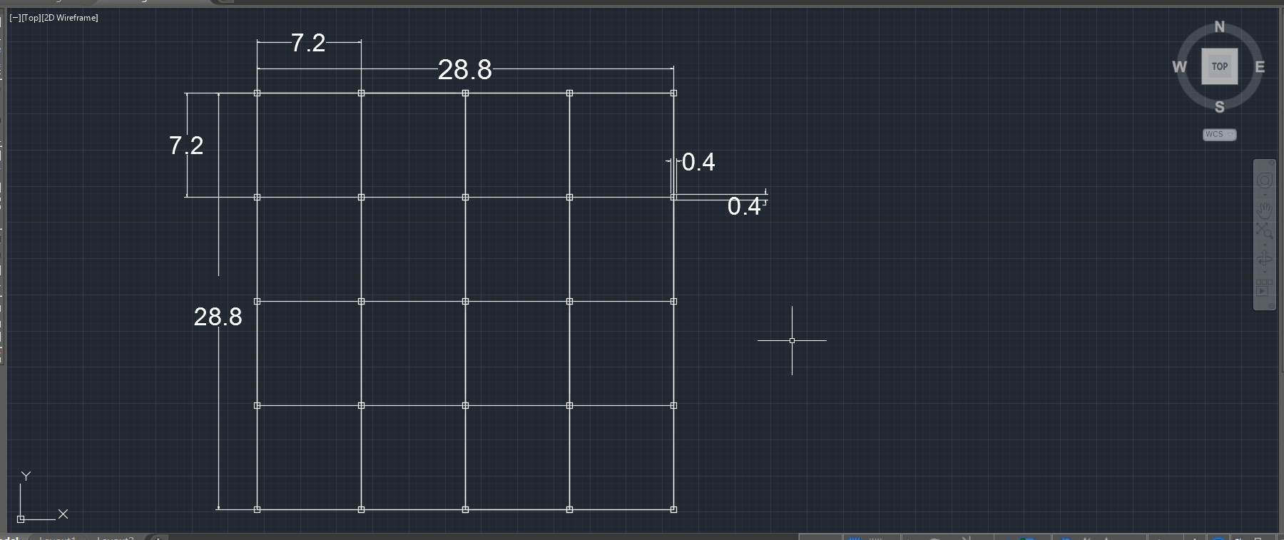

RESULTS AND CONCLUSIONS
After calculation of the elements of the precast structure, we got the following results.


Following is the table showing the reinforcement details of the elements of the precast structure. We have also added attachment of the drawings of the elements of precast structure.

1. Slab divided into panels
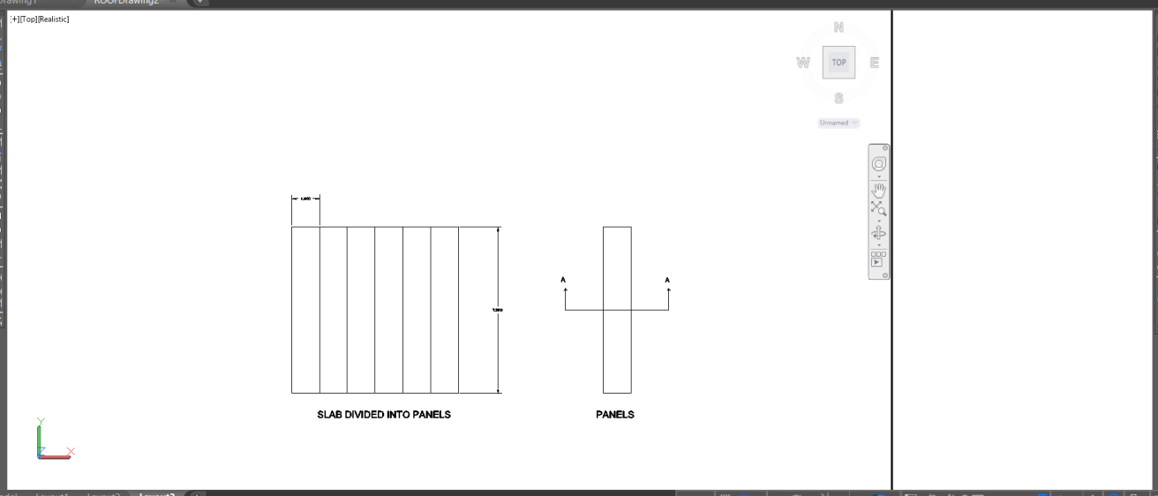

2. cross-section of slab

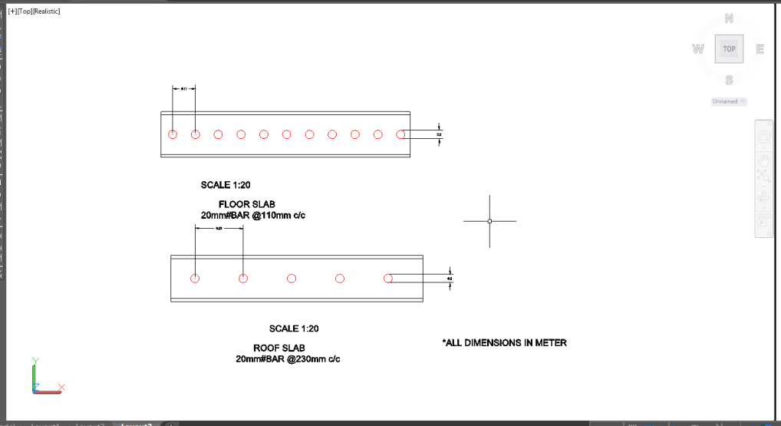

3. Beam rested on Column
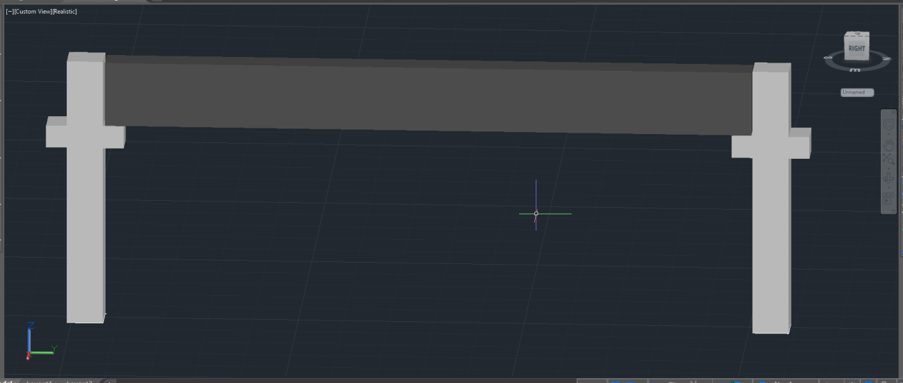

4. Cross section of Beam

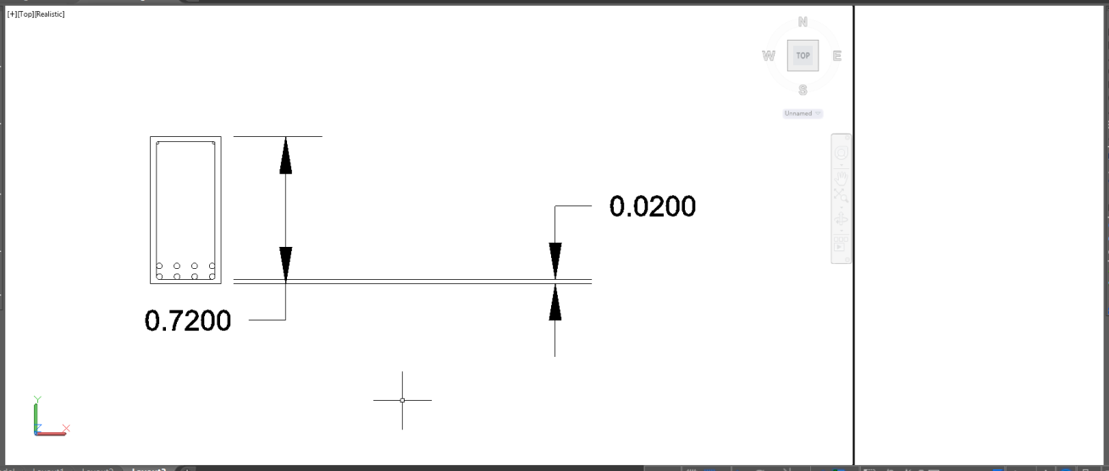

5. Cross section of beam

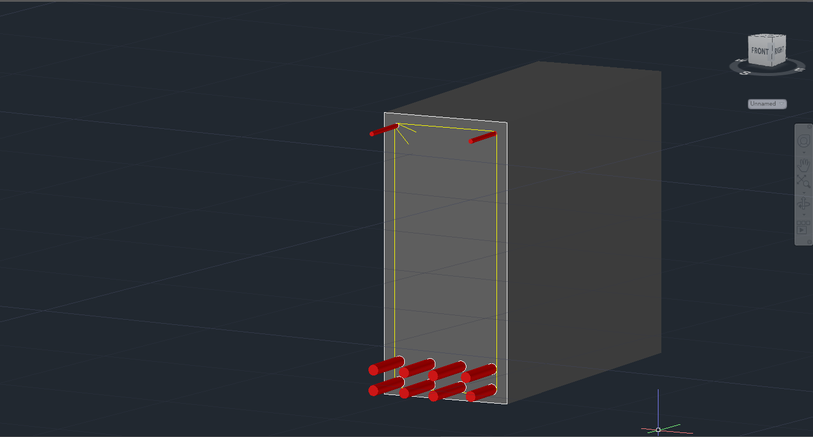
8bars-28mm# with 2 legged 8mm stirrup@95mm c/c

6. Cross section of Roof Beam

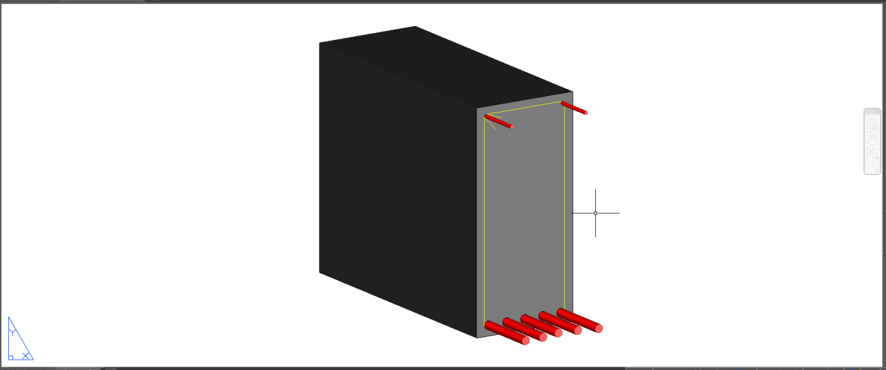
5bars-28mm# with 2 legged 8mm stirrup 480mm c/c

7. Cross section of Column

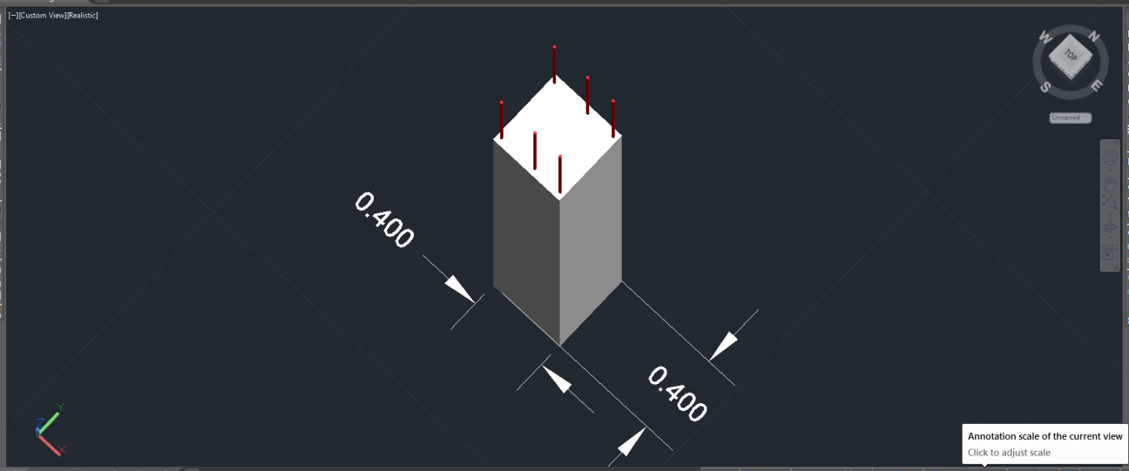
6 Bars-16mm#with 2 legged stirrups 6mm#@250mm c/c
Following were the Cross-Sections of different elements of precast concrete structure.

CONCLUSION

In India, the use of pre-cast concrete is extremely limited. But, off late there has been a significant rise in the use of pre-cast from a number of companies. Considering its advantages it shouldn't be too long before the use of pre-cast in construction is widely accepted by construction companies all over India.
It is getting some attention mainly in cities like Chennai, Bangalore, Pune, Mumbai, projects for residential and commercial buildings are constructed using precast technology. And one point to note here is that these cities lie in low seismic zone and hence it is easy to design buildings using precast technologies for these regions.

REFERANCES
1. Bindurani.P, A. Meher Prasad,and Amlan K. Sengupta . “Analysis of Precast
Multistoreyed building – a case study”, International Journal of Innovative Research in Science, Engineering and Technology, Volume 2, Special Issue 1, December 2013.
2. Fabio Biondini, Alessandro Palermo and Giandomenico Toniolo, “Seismic
Performance of concrete structures exposed to corrosion: case studies of low-rise precast buildings”,Journal of Structure and Infrastructure Engineering, Vol. 7, January–February 2011.
3. Ghosh S. K, Nakaki, Suzanne Dow and Krishnan Kosal . “Precast Structures in Region of High Seismicity”, International Journal of Civil, Architectural, Structural, Urban Science and Engineering,Vol.6,November 2006.

